JANE AUSTEN: MYTH, REALITY, AND GLOBAL CELEBRITY
Course Outline and Questions
Reformatted course outline and questions from the web, with (short descriptions) for each unit.
WEEK 1: EDUCATION AND READING
Welcome
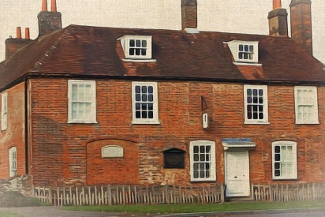
Gillian Dow and Kim Simpson welcome you to the course and explain some of the topics we will cover. This is also our chance to find out about you and why you are interested in Jane Austen.
- Welcome to the course (video)
- Join our online community
- Mark your location on an interactive map
- Tell us why you have joined this course in the comments area
- What does Jane Austen mean to you? (video)
- What does Jane Austen mean to you?
- What did Jane Austen mean to others? (Reading Experience Database)
- What was Charlotte Bronte’s opinion of Austen’s work? Are you surprised by any of her comments?
- Now try a search for other famous readers, such as E. M. Forster or Virginia Woolf. What are their opinions of Austen?
- What do you find? What do these accounts tell us about how Jane Austen’s novels circulated in the nineteenth century?
- Now try to find evidence of servants and labouring class readers of Austen. How many can you find? Does this tell us anything definitive about Austen’s readers, in either the 19th or the 20th centuries? Write your answer in the comments box.
- Location, Location: the places that mattered to Austen (article: family homes)
- Have you visited any of these locations? Tell us about your experience there.
- References to Jane Austen or to the 18th century period in which she lived are often found all over the world. Do you have any English-style or Austen-era locations near to you? Tell us about them.
An 18th Century education
In this section, we consider the kind of education Jane Austen would have experienced and how this shaped her writing. We also reflect on male and female education in 18th century England.
- Introduction to week 1 (video)
- What do you hope to learn this week?
- Grand tours and letters to daughters (article: male vs. female education in 18th Century)
- From what you know of Austen’s work, what do you think Austen’s view of these ideas were?
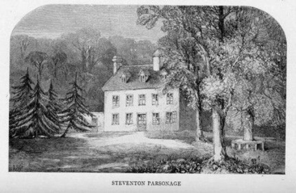
- Tell us what you think about the ideas raised by this article
- Valuing Female Education in the late eighteenth century (article: two theories)
- What position is each writer taking? What is her argument?
- What is important to each writer?
- Are their concerns in any way still relevant today?
- Female education in Austen's novels (article: novel extracts)
- What do the following extracts from Jane Austen’s novels tell us about her thoughts on women’s education?
- Can you find evidence that she is a feminist, like Mary Wollstonecraft, or is she keeping in line with more restrictive contemporary ideals of femininity?
- Are there other moments in Austen’s novels which suggest Austen’s views about education?
What would Austen have read?
In this section, we consider Austen's library and what she herself would have read. Many of the books which she knew are now housed at Chawton House Library.
- Introduction to Jane Austen's reading (video: Chawton library, article: Mary Brunton’s Self-Control)
- What do you think Austen means when she says ‘without anything of Nature or Probability in it?’
- What might Austen mean when she talks about ‘the natural, possible, every day’ in relation to Mary Brunton’s Self-Control?
- Think about the quotations above in the light of the novel being a new genre at the time. How far might Austen’s comments be seen as critical of the writing of her time? Do you think she is aligning herself with the writing of the time, or defining herself against it?
- Exploring the Godmersham Park Library (digital recreation of Edward Knight’s library at Godmersham Park)
- Does the type of material housed in the library at Godmersham Park surprise you? Can you draw any conclusions about what shelving system was being used?
- What conclusions can we draw about Austen’s own reading?
- What does Austen’s reading tell us about her writing? (video: family reading and Austen’s writing process)
- Look at the examples of Austen’s own extant manuscripts linked in the ‘references’ section below.
- What insights into how an author wrote can we glean from examining their manuscripts? Why do you think no manuscripts to Austen’s published novels survive today?
- The importance of reading in Austen's novels (discussion: extracts)
- Think about the Austen novels which you have read. Are there any characters for whom reading is important? Tell us who and why reading is important to them.
- If you haven’t read any of Austen’s novels, consider how you might use reading to build characterisation if you were writing a novel. What would a preference for Jane Austen’s novels tell us about a character, compared to, say, a love of Fifty Shades of Grey by E.L. James, or detective novels, or historical non-fiction? What types of literature would you use to suggest naivety, shallowness, or intelligence?
- Opinions of the novel: the 18th century context (British Fiction 1800-1829 database of reviews)
- What did contemporary reviewers make of Austen’s novels when first published? Does their attitude surprise you?
- What do their comments tell us about how novels in the 18th century were read and valued?
Summary activities
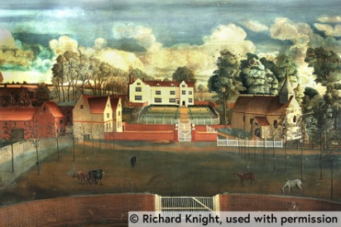
In this final section we summarise the main points covered this week, encourage you to reflect on what you've learned and consider which ideas you wish to explore further.
- Video update on the week's activities (video)
- Test your learning (test for those who upgraded)
- Reflection (discussion)
- What have you found to be good, useful or interesting this week?
- What actions will you now take to learn more about these topics?
- What questions, if any, have arisen for you?
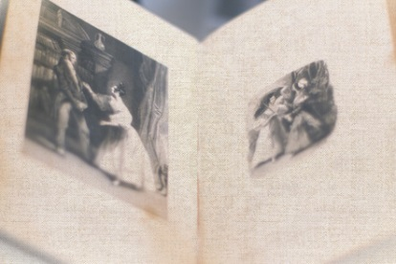
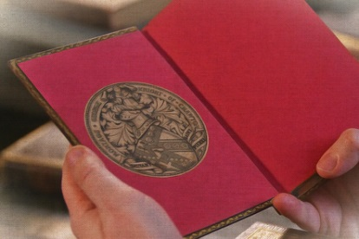
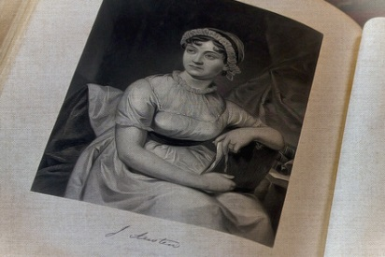
- Further study with the University of Southampton (new Master of Arts in Jane Austen)
WEEK 2: INFLUENCES AND AFTERLIVES
Introduction to week 2
In this second week, we will consider Austen's influences and 'afterlives.' We will look to her life and surroundings for influences and explore how her family and her biographers shaped the idea of Austen we have today.
- Welcome to week 2 (video)
- What do you hope to learn this week?
Influences on Austen: the arts
In this section, we consider other influences on Jane's writing. We explore music and the arts. We also take a walk in the Chawton House gardens to think about the importance of gardens in Austen's work.
- What are the other possible influences on Austen's writing? (discussion)
- So far, we have considered questions about education and Austen’s reading. There are likely to have been many other influences on her writing.
- What do you think? What other influences might have affected what she chose to write about?
- Austen and the theatre (article: influence of the theatre on Austen)
- Do you know of any other references to Shakespeare in Jane Austen’s novels or letters? Share them in the comments below.
- What other similarities do you see between Austen’s work and Shakespeare’s work?
- The writer Paula Byrne argues in her book Jane Austen and the Theatre that Austen ‘is akin to Shakespeare in her perception of the ambiguity of truth.’ What do you think she means? Do you agree?
- Music in Austen's life (article and digital archive of Austen family music)
- Follow the link to the archive and look at the volume Jenkyns 3. How many different handwritings can you find there? What does this tell us about the Austen family and music?
- Find a musical scene in Austen’s fiction and tell us how the activity of music making is used in Austen’s depiction of character or plot.
- The virtual drawing room (activity)
- Are there any musicians amongst you? Try playing something from the Austen family music books and then sharing your music in our virtual drawing room. What was it like to listen to [the music]?
- Walking with Austen: garden and landscape (video: garden elements and functions, and in Austen’s fiction)
- What does the narrator want us to understand, here, about English tradition and the nature of the English country estate?
- Reflecting on landscape in Mansfield Park (reading and discussion)
- How does Austen use landscape in this extract?
- Does Austen’s use of landscape here help us understand the moral values of the characters featured?
Influences on Austen: money and capital
In this section, we consider money in Austen's life and works. How did money (or the lack of it) impact on Austen's own life and how does money impact on the life of her characters? What kinds of capital are important for Austen?
- Money in Austen's life (article: Austen’s finances and impact on her life)
- Austen’s annual accounts and her letter indicate that she prioritised being smartly dressed. Why might ‘outward appearances’ have needed to be prioritised over other things?
- Would the same priorities apply today?
- What are Austen's characters worth today? (articles and currency converter)
- [After running the currency converter] What do you discover [to be Darcy’s worth today]?
- Where would Jane Austen herself have fitted into the economic range of her characters – both before and after she began receiving payment for her writing? (you may need to look back at the previous step to remind yourself how much money she earned from her writing).
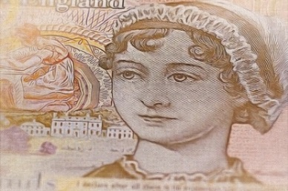
- Why do you think Austen included such variations of wealth within her novels? Which characters have the most power because of their wealth – and how do they exercise it? What point(s) is Austen making about money through her characters?
- Money and the marriage market (article and eligible spinster lists)
- Who would have been the most sought after women on this list?
- Tell us what you think about this directory - and the fact that it exists at all.
- Social capital in Sense and Sensibility (Ch. 33, John Dashwood and Elinor)
- See how many different sorts of capital (financial, social, physical, familial) are embedded into this conversation.
- What do the sisters’ hopes of a good marriage depend upon? What is working in their favour?
- Why might John Dashwood be particularly keen for Elinor to marry Colonel Brandon?
- Why might Jane Austen herself have been keen to emphasise the importance of non-financial ‘capital’?
Biography: how Austen was described to the world
We explore how Jane Austen was described to the world by others and her later celebrity. We consider how descriptions of Austen were managed by her family and we reflect on the role of portrait in shaping our ideas of who she was.
- Unmasking ‘A Lady’: Henry Austen’s 1817 Biographical Notice (reading and discussion)
- What impression of Austen does this leave in you? Is it an image of Austen which you recognise? If so, in what ways?
- What image of his sister does Henry Austen wish us to have?
- Biographies of Austen: creating Jane (video: how Austen’s family presented her life and edited her letters )
- Who was Jane Austen? Thinking of books and biographies you may have read, what is your impression of Austen?
- How would you say your idea of Austen has been shaped by the books you have read and films you have seen?
- Portraits of Austen (article: descriptions and portraits over the years)
- Tell us what you think about these different portraits. Do they fit with your idea of Jane Austen?
- Austen the celebrity (article: the phenomenon of celebrity and how it applies to Jane Austen)
- What (if any) items related to Austen do you possess? Books? Or other souvenirs? Why are these items important to you?
- What are the implications in calling someone a ‘Janeite’? An ‘Austenite’? Do you consider yourself either, and if so why, or why not?
- Celebrity in the 18th century (article: celebrity culture in Austen’s lifetime, and her own interest in celebrities)
- Celebrity exists and grows over time and is adaptable to fulfill changing cultural interests. Why do you think Jane Austen’s life and works have so much resonance today? Why does the Austen ‘brand’ appeal beyond enjoyment of the novels themselves?
Summary activities
In this final section we summarise the main points covered this week, encourage you to reflect on what you've learned and consider which ideas you wish to explore further.
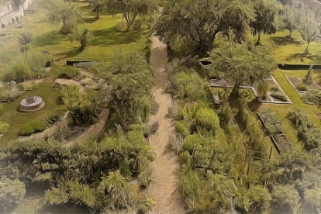
- Video update on the week's activities (video: divorce, scandal, gossip)
- Test your learning (test for those who upgraded)
- Reflection (discussion)
- What have you found to be good, useful or interesting this week?
- What actions will you now take to learn more about these topics?
- What questions, if any, have arisen for you?

WEEK 3: ADAPTATION AND LEGACY
Welcome to week 3
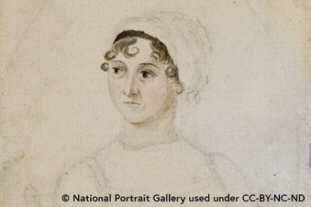
In this final week, we consider Austen's legacy. How have her novels been adapted for the screen? How is she understood by international audiences who read her work in translation? How do we curate her memory for modern audiences?
- Welcome to week 3 (video)
- What do you hope to learn this week?
Austen in translation: from Chawton to the world
In this section, we explore how Austen's novels reached the wider world and how far
different translations have influenced global perceptions of who Jane Austen was.
- Austen's entry into the global marketplace (article: other languages and countries, 1813-1821)
- What do you think Jane Austen would have made of her posthumous global reputation?
- If you are in a country other than the UK, what other British authors from the 18th and 19th centuries are popular where you live? If you are in the UK, what writers from other countries have you read?
- Austen in translation: from Chawton to the world (video: the first translations)
- Isabelle Bour talks about her idea of the perfect translation. What features do you think the perfect translation of Austen should contain?
- Have you read any of Austen’s novels in translation? Tell us about the translations that you have read.
- Understanding 'sensibility' in Austen's time (article: 18th Century meaning and “cult of sensibility”)
- If you have read Austen’s Sense and Sensibility, in what ways do you think she is engaging with debates about whether sensibility is a positive attribute?
- If you have not read Austen’s novel, tell us whether you think sensibility is a positive attribute?
- Discover Austen where you are (activity)
- Look at an edition of one of Austen’s novels then answer these questions:
- Who is the publishing house? What kind of publications are also on their lists?
- What cover image is being used? Does it portray the world of Austen’s fiction? An abstract idea?
- Is there a publishers’ description on the back cover (the ‘blurb’), or elsewhere? What kind of reader is the description directed at?
- Is there an introduction? Are there notes? What kinds of things are being explained for the readers, and why?
- Are there illustrations? What scenes have been selected for illustration?
- Who is being marketed as the intended reader? Do you agree – or disagree – with the publishers’ choices?
Adaptations of Austen
In this part of the course, we consider adaptations of Austen. We reflect upon what it means to create a 'good' adaptation and explore recent adaptations by international film makers.
- Adaptation: what does a 'good' adaptation look like? (video: the nature of adaptation, authentic or expansive)
- What features do you think a good adaptation of Austen’s work should feature. You may wish to consider films, plays or any other kind of adapted work.
- The idea of Austen: what is it to be 'Austenesque?' (video: a type of story, or also as a “brand”)
- (Whit Stillman’s film “Metropolitan”): In what ways might it be described as ‘Austenesque?’
- What makes something ‘Austenesque’ for you?
- Is Mansfield Park Austen's most radical novel? (video: the “present absence” of slavery, and Fanny’s nature)
- Do you think Austen should have addressed the issue of slavery in the novel Mansfield Park? Would it have improved the novel?
- If you haven’t read the book, tell us what you think about the idea that Austen should have addressed political issues of the day (i.e. slavery) in her novels. Is this an area in which adaptations can extend her work? Or would they then become ‘unfaithful’ adaptations?
- Mansfield Park: is Fanny Price a worthy heroine? (poll and discussion)
- Is Fanny Price a worthy Austen heroine?
- Thank you for your response! Now tell us why you chose your answer in the comments section.
- Review an adaptation of Austen (activity)
- Think of a film (or other adaptation) of an Austen novel, or watch a new one. Tell us what you think of it in the comments area. Make sure you tell us:
- what the adaptation is (e.g. film, play, cartoon, etc.)
- which novel it is an adaptation of
- why you like it or don’t like it
- why you think it is a good adaptation of Austen’s work
Telling Austen's story
In this section, we think about how modern archivists and curators tell the world about Jane Austen. We consider how her story is told at the Jane Austen's House Museum and through Chawton House's regularly changing exhibitions.
- Inside the Jane Austen's House Museum (video: curating challenges, and some special Austen artifacts)
- What can we learn from looking at the [JA House Museum] house, living space and artefacts related to an author?
- Does it assist in our understanding of that author and their works?
- Curating Austen’s story: how do you begin? (video: assembling a display)
- Tell us about the best museum or art gallery exhibition (on any topic) which you have visited.
- What was it about the exhibition that made you enjoy it so much?
- Curate your own fantasy Austen exhibition (activity)
- How would you curate your ideal, fantasy exhibition about Jane Austen?
- What kinds of item might you include? What story might you tell?
- Think of three or four items, and how you would link them together, as well as how to provide captions for them individually.
Summary activities
In this final section we summarise the main points covered this week, encourage you to reflect on what you've learned and consider which ideas you wish to explore further.
- Video update on the week's activities (video: What becomes canon? Other women writers of her time?)
- Test your learning (test for those who upgraded)
Closing words
A farewell from our educators and some ideas for further reading and study.
- Goodbye! (video)
- What next? (other ways to learn)
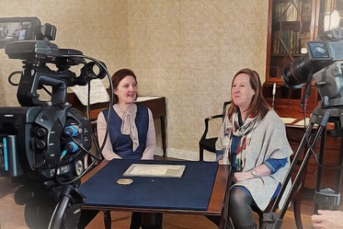
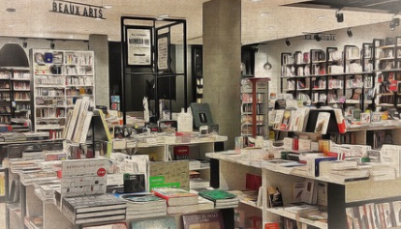
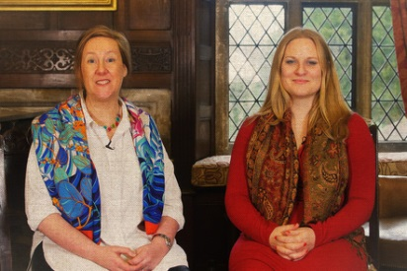
- Further reading on Jane Austen (list)

