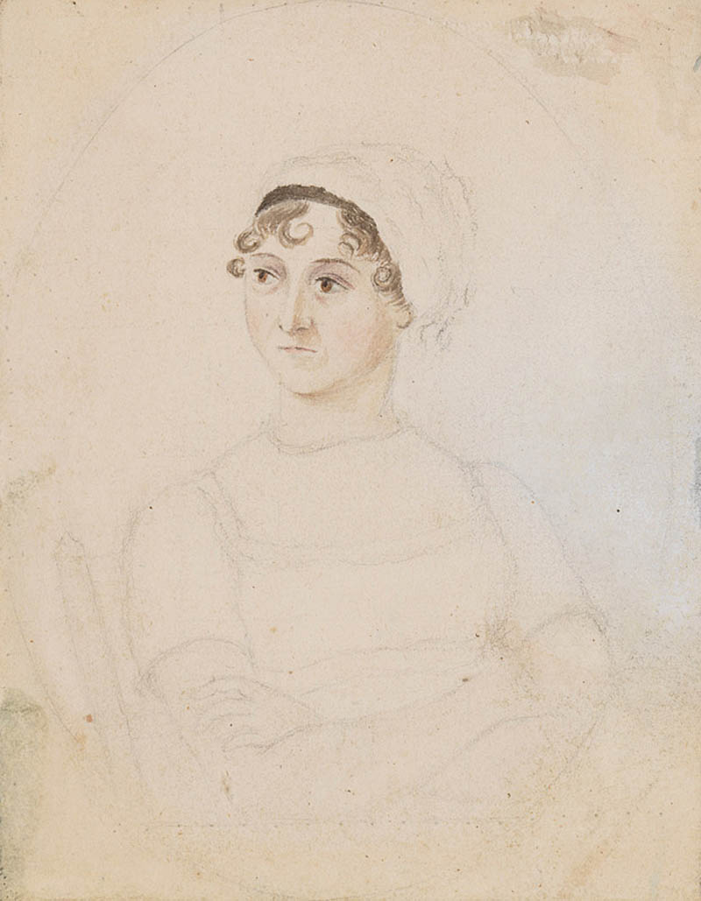
1810 pencil/watercolor sketch, by Cassandra Austen,
Jane Austen’s sister.
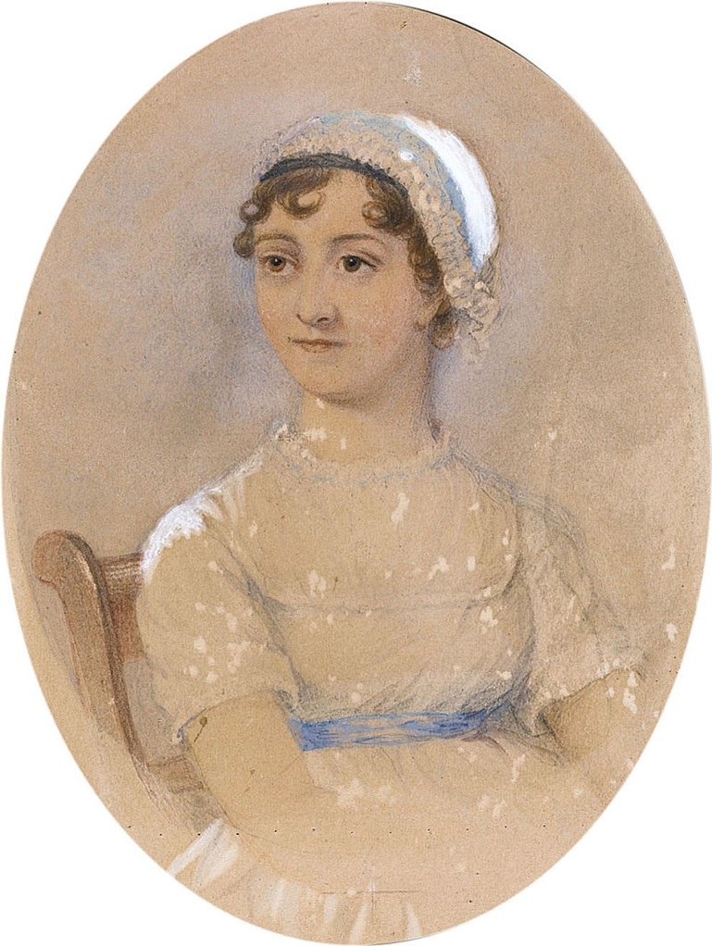
1869 watercolour, by James Andrews, based on
Cassandra’s sketch, commissioned by J.E. Austen-Leigh.
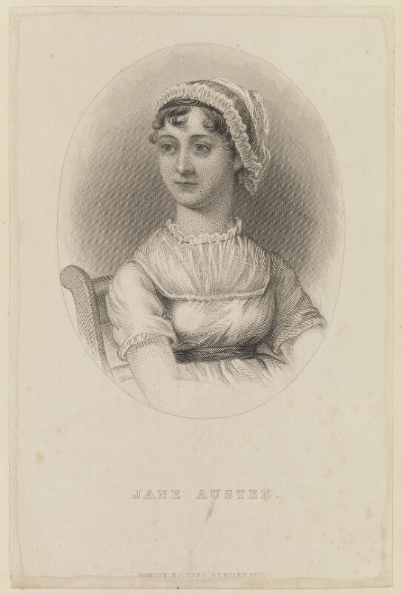
1870 engraving, by William Home Lizars, based on Andrews watercolour, used by J.E. Austen-Leigh for his Memoir of JA.
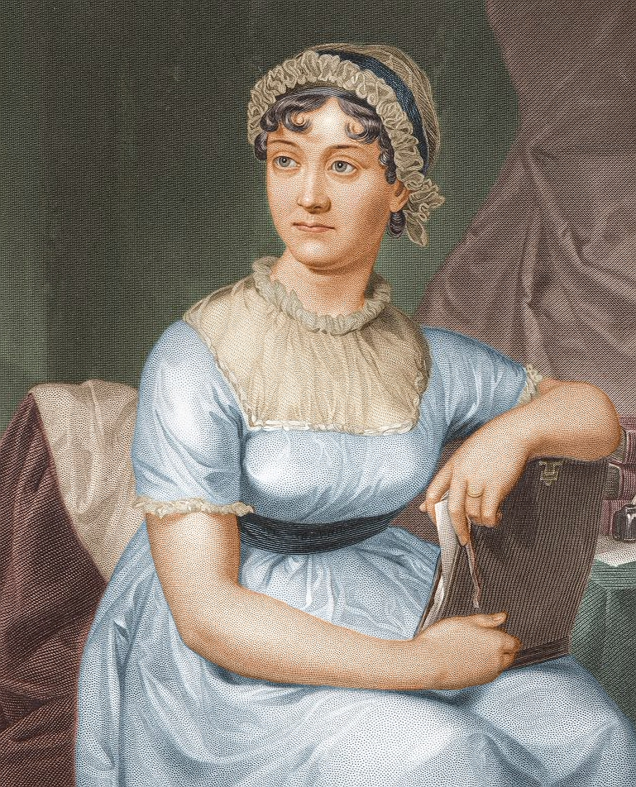
1873 re-engraved for Portrait Gallery of Eminent Men and Women of Europe and America. Inexplicable wedding ring!
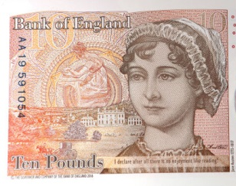
2017 Jane Austen £10 bank note,
new version, based on the Lizars engraving.
Lezars engraving close-up for comparison.
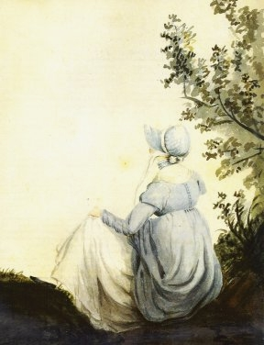
1804 watercolor, by Cassandra Austen.
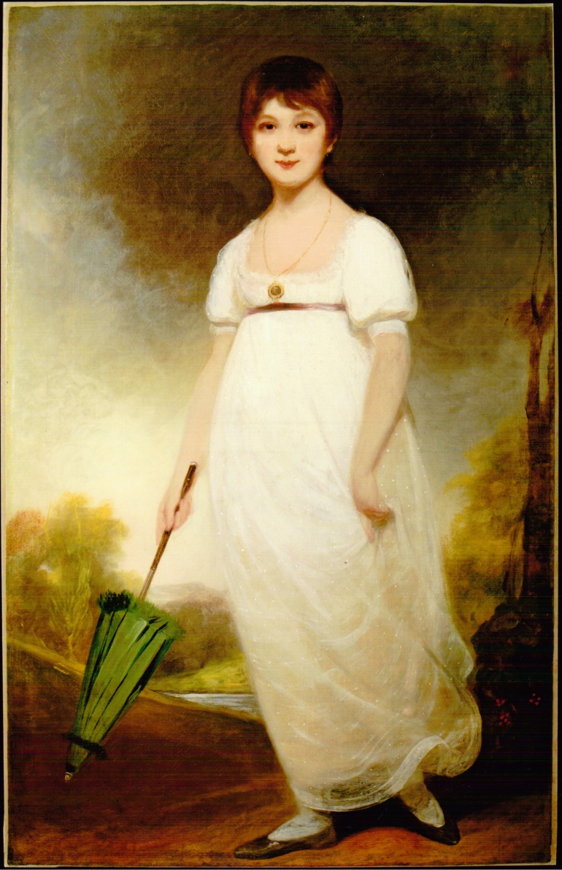
1788(?) painting, by Ozias Humphry (?), aka "Rice Portrait," believed by some to be a portrait of Jane Austen at age 13.
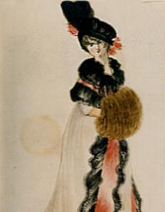
1815 watercolor, by James Stanier Clarke, thought by some to be a portrait of Austen, possibly showing patchy skin pigmentation from of her fatal illness, Addison’s disease.
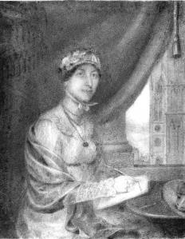
c. 1815, unknown, discovered in 2011 by author Paula Byrne. On the back is written ‘Miss Jane Austin’ (sic).
View from window appears to show Westminster Abbey.
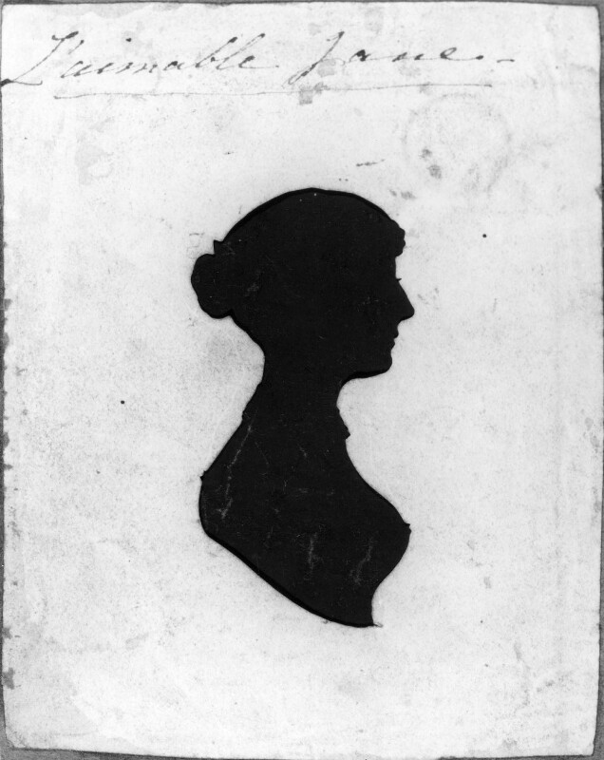
c. 1810-15, unknown, “L’aimable Jane.”
This silhouette—a common token of friendship, and possibly done by a professional profilist in Bath—was pasted into a volume of the 1816 2nd edition of Mansfield Park.
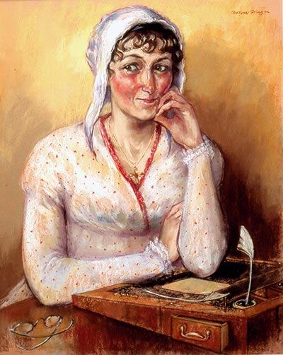
2002, painting, by Melissa Dring, forensic artist, commissioned by the Jane Austen Centre in Bath (see article).
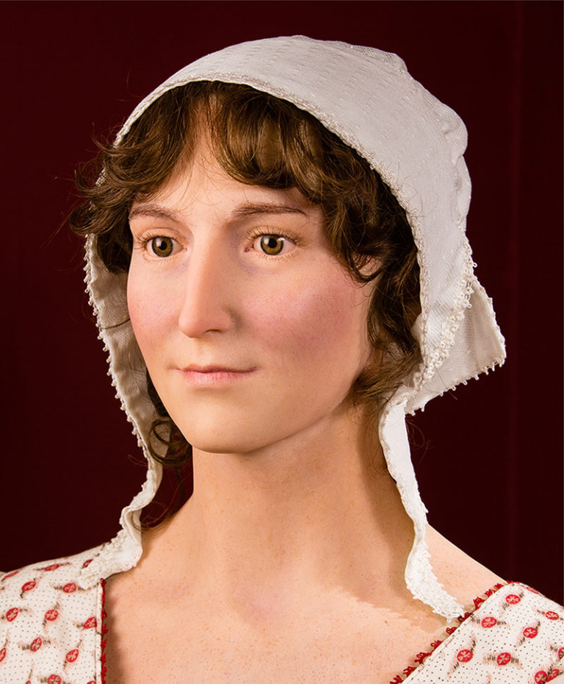
2014, waxwork (close-up), by sculptor Mark Richards, working closely with Melissa Dring (and her 2002 portrait), hair and color artist Nell Clarke, and designer Andrea Galer (who dressed the completed figure in authentic period dress).

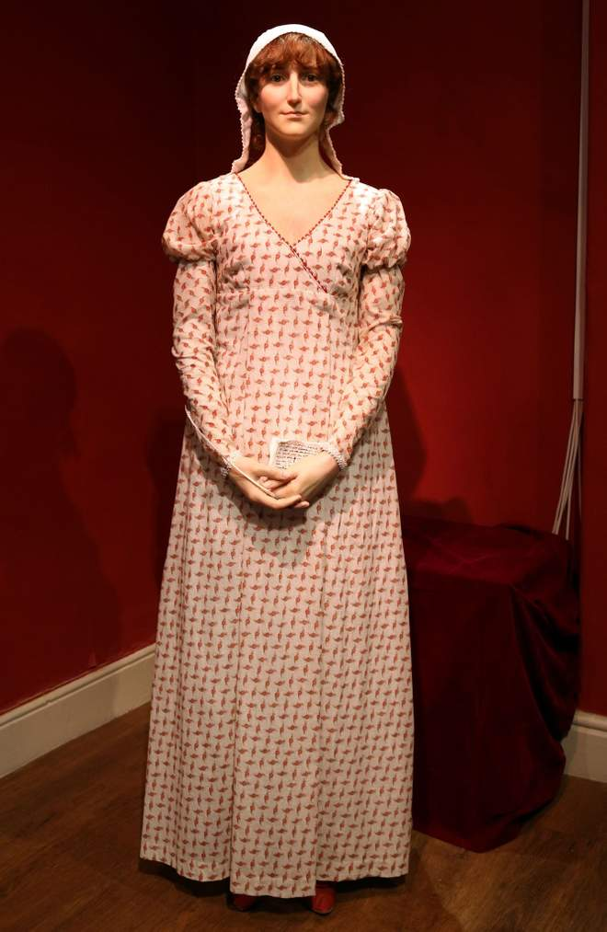
Full 2014 waxwork at Jane Austen Centre in Bath

